# Chapter 4: Project Management

## Chapter Overview

Write something here

## Project Management Methodology

For the Project management methodology of this project, the PRINCE 2 Project Management methodology has been selected. PRINCE 2 is a project management framework that is scalable and can be adaptable to any type of project with ease. PRINCE 2 focuses on dividing the work process of a project into manageable and controllable stages. PRINCE 2 is a widely used standard among many professionals in the industry and is a flexible project management methodology that can accommodate with changing requirements of a project. PRINCE 2 is based on seven principles. These can be stated as follows, ***Continued Business Justification, Learn from Experience, Defined Roles and Responsibilities, Manage by Stages, Manage by Exception, Focus on Products, Tailor to Suit Project Environment.***

When considering these principles, and as we can see that the project being considered in this research does have tendency for requirement alteration as progress is being made and there is much to learn and discover through the life cycle of the research. PRINCE 2 can be considered a suitable project management framework to be employed for the management methodology of this project.

## Potential Risks and Mitigation Plans

The following tables define potential risks and its respective mitigation plan.

|  |  |  |  |  |  |
| --- | --- | --- | --- | --- | --- |
| **Risk 01** | Lack of Domain Knowledge | | | | |
| **Risk Level** | High | **Phase** | All | **Frequency** | Medium |
| **Mitigation** | * Perform an in-depth review and analysis of currently available literature regarding domain and relevant topics | | | | |

|  |  |  |  |  |  |
| --- | --- | --- | --- | --- | --- |
| **Risk 02** | Inability to meet set deadlines | | | | |
| **Risk Level** | High | **Phase** | All | **Frequency** | High |
| **Mitigation** | * Meet with mentor and keep track of progress made on a regular basis. * Keep personal deadlines for each task by breaking it down further within main timeline | | | | |

|  |  |  |  |  |  |
| --- | --- | --- | --- | --- | --- |
| **Risk 03** | Changes in Project Requirements | | | | |
| **Risk Level** | High | **Phase** | All | **Frequency** | Medium |
| **Mitigation** | * Maintain priorities and make changes accordingly so as not to affect project timeline | | | | |

|  |  |  |  |  |  |
| --- | --- | --- | --- | --- | --- |
| **Risk 04** | Technical limitations | | | | |
| **Risk Level** | High | **Phase** | Implementation | **Frequency** | Medium |
| **Mitigation** | * Alter method of development to find work around said limitation | | | | |

|  |  |  |  |  |  |
| --- | --- | --- | --- | --- | --- |
| **Risk 04** | Progress loss due to loss of data | | | | |
| **Risk Level** | High | **Phase** | All | **Frequency** | Low |
| **Mitigation** | * Regular data back-ups to cloud storage * Maintain Github repository for code management * Have local backup of project if drastic change is being made in case roll-back is necessary. | | | | |

## Work Breakdown Structure

Please refer on Appendix A

## Gantt chart

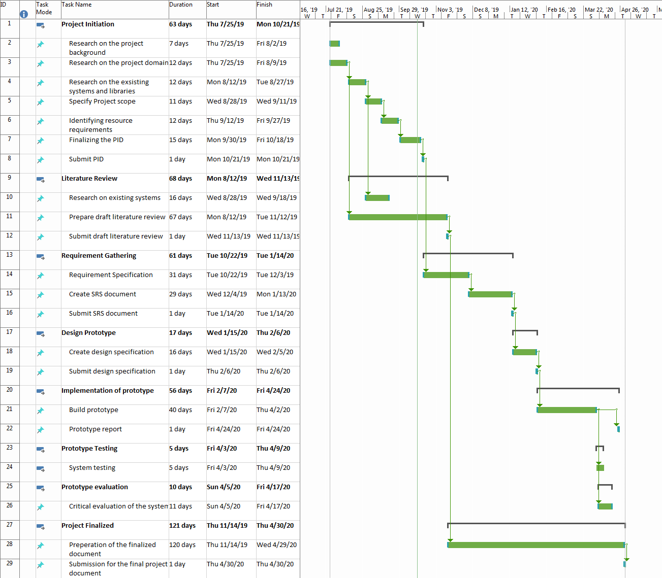Please refer on Appendix B.

## Social, Legal, Ethical and Professional Aspects

|  |  |
| --- | --- |
| **Social** | **Ethical** |
| * The platform will be available to anyone who wishes to use the software under a Standard End User License Agreement (EULA) | * Creating inaccurate result images - * In terms of an ethical standpoint, for data which might define county boundaries for example if produced inaccurately can cause a lot of issues if used for high influential statements. |
| **Legal** | **Professional** |
| * Computer Miss use Act Violation | * Violation of BCS Code of Conduct * Due regard for public privacy |

## Chapter Summary